Class use of Create to Learn and Create to Learn website

In WRT235: Digital Writing and Rhetoric at URI, students use Create to Learn as their guide throughout the projects of the class.

The class begins with students completing forms in Chapter 1. Their responses guide the opening discussions.

Digital authorship: a checklist: Chapter 1 (https://forms.gle/C1FcYk7anfBUv7JP6)

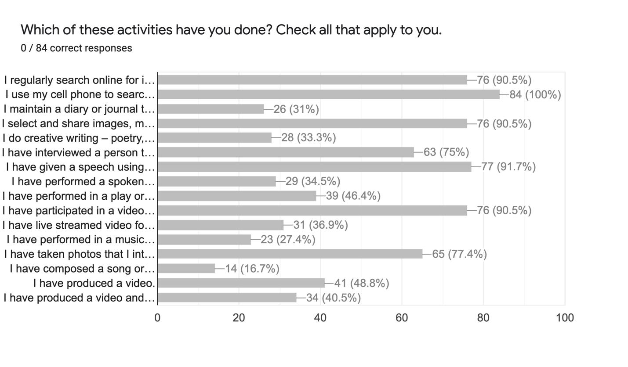

3 Samples from Identity Reflection Activity: Chapter 1 (https://forms.gle/bsSyg1ZsUz4qxPyx9)

When were you a leader in creating a project? When were you a contributor or a collaborator in the creative productions of others?
In a previous nursing clinical, I had to participate in a inter-professional education (IPE) project where students from different majors would have to contribute to a care plan for a patient. Since I was the only student from nursing, I had to lead the nursing aspect of care for the patient. I was a contributor in a creative production when I took a theatre class freshman year. I had to collaborate with other students to produce a play.
I have created a good amount of projects in the past and am currently going to be creating projects for campus recreation as a photographer/marketing team member. I also create content for PRSSA as their social media coordinator. I often contribute/collaborate with friends who make content for their social media pages or just for fun.
Throughout my life I have always been creative and enjoy being a leader. When I was in high school, I was the leader and a collaborator in my fashion design group, this means I came up with the overall garment design, drew the sketches and created pattern pieces while assigning and overlooking everyone their specific job in creating the overall piece.

Describe the product you created and the process you used to create it. What do you remember liking and disliking about the experience?
During the IPE project, we created a holistic care plan for a patient who had experienced a stroke which caused issues in her everyday life. As a group, we had to present ways that she could modify how she does things so that she can live an independent life following her stroke. During the project, I enjoyed being able to help someone be able to return to their normal everyday life as best as they could. Something I disliked was when members of the group has disagreements about subjects and needing to solve them.
I have created both pictures and videos in the past. I often shot videos with my phone and then used iMovie to edit. I did not like the editing as much as the creating aspect because I felt it was tedious but I liked the end result as well as the process of shooting.
The product we created was a ballgown which took a lot of time, preparation and work. The process to create the garment was long and tiresome, it consisted of developing a theme, sketch, mood board, and the physical process of cutting and sewing. The best and worst part of the experience was working together. This is because it is fun to work in groups and get to know your peers but, it is hard to see eye to eye with everyone.

If you could create any kind of media product at all (with no limitations), what would you want to create? Why would you want to create it?
If I was to create a media project I would create a lifestyle blog/Instagram page focusing on food, exercise, and skincare. I would want to create this because healthy lifestyle is something that I am very passionate about and would love to share my knowledge about the human body and health to hopefully help people live a healthy life.
A media product I would love to create would be a clothing website, this is because I feel as though all clothing companies have a similar website. I would really enjoy thinking outside the box to create an entirely different shopping experience for a customer when they are online shopping.
If I could create any kind of media product I would want to do something similar to twitter but for college campuses. I think this could be useful and filled with resources for the students. Study tips and tricks can be shared along with campus updates. If a road is closed or a class is canceled this platform can be used to get the message across. I think this would be very useful. I know if I was a student I would love a platform like this.

What scares you most about the idea of becoming a digital author?
Something that scares me about becoming a digital author is the criticism and rejection that can come from publishing your work.
I think what scares me the most is not being thought of as genuine, I strive to put out as genuine products as possible and would hate to not come off that way.
What scares me most about becoming a digital author is the idea of not being able to unplug. I want to not be 100% dependent on the internet. Over the years we’ve all seen technology grow, but we cannot forget about the written texts that are still out there and hold so much value.

Creating a Blog
This is the first project of the class. It is a holdover from the original class, Writing in Electronic Environments, but easily fits into Digital Writing and Rhetoric using Create to Learn and the Create to Learn website as examples.

Here is the link to a copy of the assignment on our class page: (click HERE)

Using the Creative Brief: Chapter 2
When Students begin their design studio project, Creating Digital Rhetoric, they are asked to complete the Creative Brief in Chapter 2 and include it on their dyad page. A link is provided for students to make their own copy of the questions and an example (Click HERE).

Students then choose the way in which they include their brief on their page.

- June and Katie chose to simply respond to the prompts on their copy of the google document and include it on their project page (click HERE and scroll down)

- Nadia and Maddy displayed their answers as text on their Google Site project page (click HERE).

- Owen and Robert differentiated by each student’s major, each creating his own brief and listing them side by side using collapsible groups of text on their Google Site project page (click HERE).

